Eurofer97 Procurement Issue
Taesuk Oh

Everyone knows that Eurofer97 (one of the RAFM steel) will be utilized for most of the Fusion Power Plants
- Enough ongoing research concerning its material characteristics
- The question is, would it be possible to manufacture on an industry scale to meet the needs.
No official report (at least I can find) that estimates annual production rate of Eurofer97 as it would be logical to have production facilities when demand for the produced Eurofer97 exists.
But, still, was able to find that it can be produced in order of couple tons!
(This is an article dating back in Dec 2015)
https://fusionforenergy.europa.eu/news/f4e-purchases-27-tonnes-of-eurofer97-for-test-blanket-modules-mock-ups/
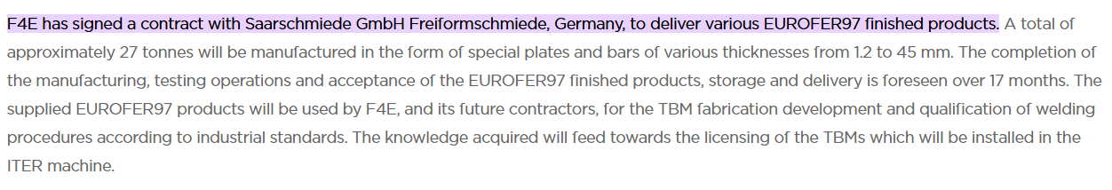
(This is an article dating back in July 2024)
https://fusionforenergy.europa.eu/news/test-blanket-modules-steel/
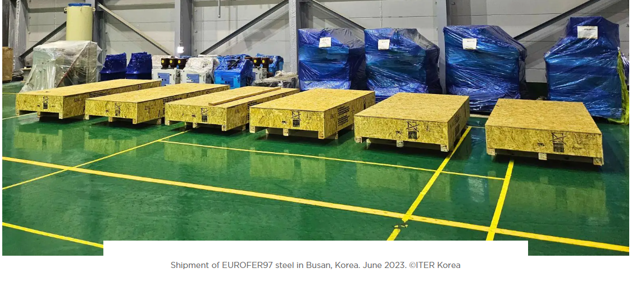
So, I expect, the production of Eurofer97 would hardly cause a bottleneck issue.

